EXPERIMENT NO: 1
AUTOMATIC TELLER MACHINE
Aim: To design a model for ATM.

Problem Statement:

Develop a model for ATM which contains a database, user to draw the money from the ATM, where the user will be logged through the pin number by inserting the ATM card, administrator will have to maintain the transaction properly and provides options to choose the type of transaction, allow the user to choose the required transaction, allow the user to enter the amount to be drawn, checks whether the user make the transaction correctly or not, Administrator will gives money to the user.

Functional Requirements:

User: The one who will have to make the transaction by inserting the card, entering the pin number, who can choose the options to make a transaction, entering the amount to be drawn, changing the pin number if necessary.

Administrator: The one who manages the database, who will perform the transaction and returns money to the user, check the pin number entered by the user; check the balance of the user, also checks the amount entered by the user is available or not and update the details after the transaction is completed.

Basic Concepts:

A model in the context of software development can be graphical, textual, mathematical, or program code-based.

An important reason behind constructing a model is that it helps manage complexity. Once the models of a system have been constructed, it can be used in different

purposes during software development which may include analysis, specification, code generation, design and testing etc…

UML is a modeling language which is used to visualize, specify, construct, and document the artifacts of a software system.

UML can be used to construct different types of diagrams which are as follows:
- Usecase Diagram

- Class Diagram

- Object Diagram

- Sequence Diagram

- Collaboration Diagram

- State chart Diagram

- Component Diagram

- Deployment Diagram

- Activity Diagram

1. ATM SCENARIO USE –CASE DIAGRAM

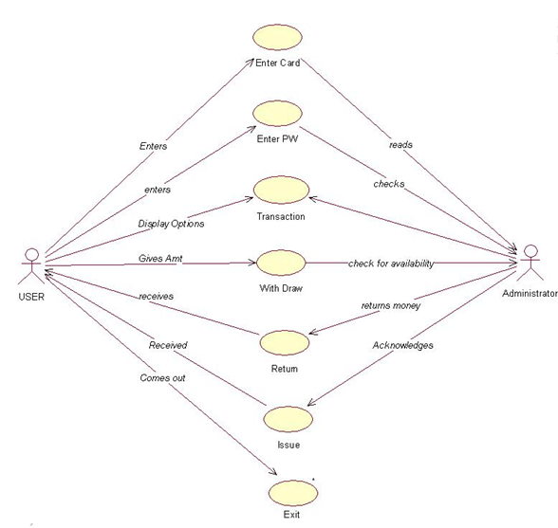

2. ATM SCENARIO ACTIVITY DIAGRAM
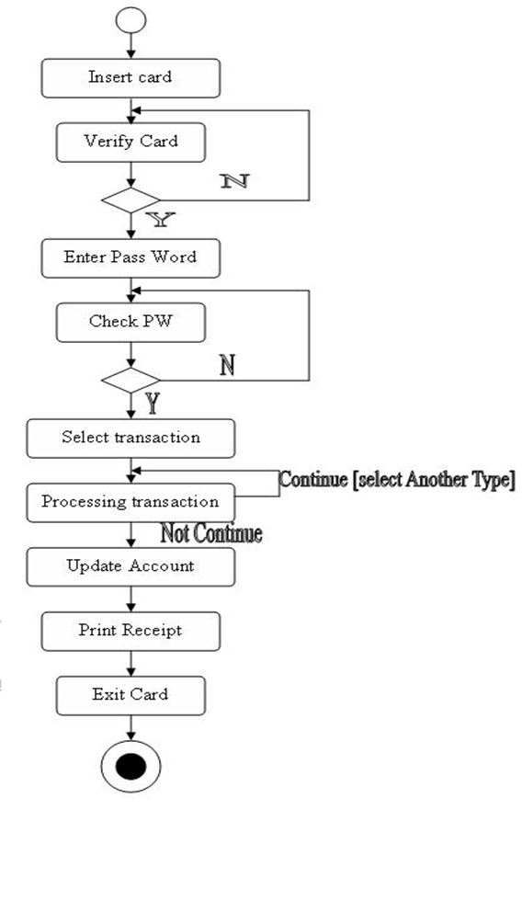

3. ATM SCENARIO SEQUENCE DIAGRAM
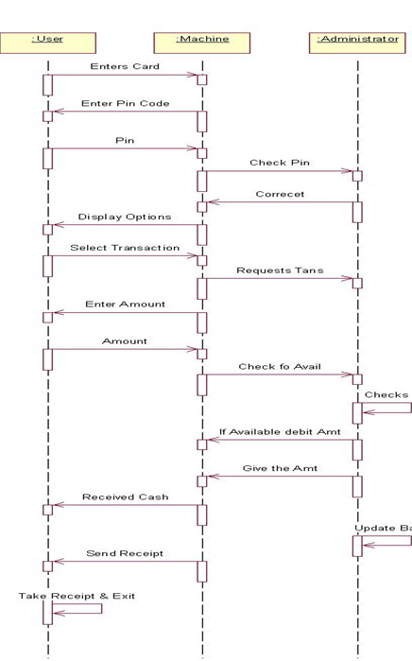

4. ATM SCENARIO COMPONENT DIAGRAM
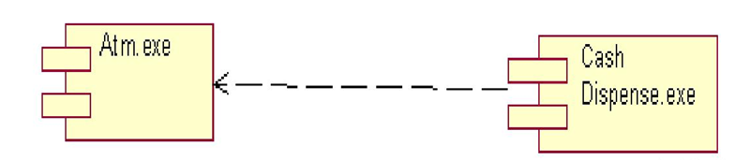

5. ATM SCENARIO DEPLOYMENT DIAGRAM

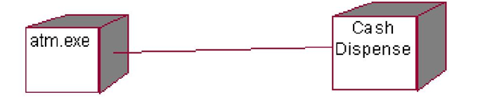

6. ATM SCENARIO STATE TRANSITION DIAGRAM
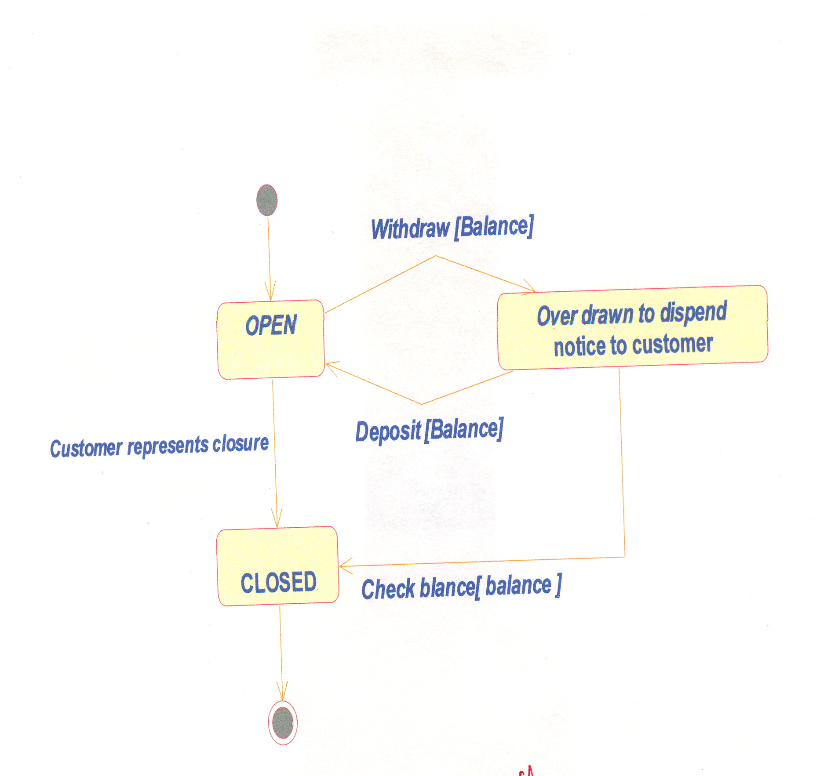

7. ATM SCENARIO CLASS DIAGRAM

